1. Racists are so colour blind they can only see in black and white.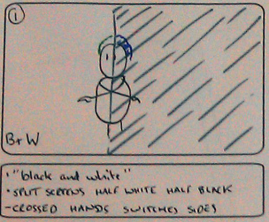  interaction: the screen is black on the left and white on the right. hands cross over, switching the 2 colours  graphics: none  sound: old fashioned super 8 projector | 2. homophobics can't think straight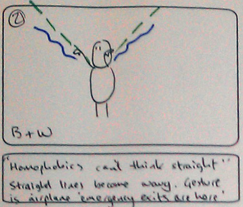  interaction: arms point out wards and straight lines/rays emit from finger tips and then start to droop  graphics:none  sound: electronic, pitch dropping | 3. Sexists should clean up the world...  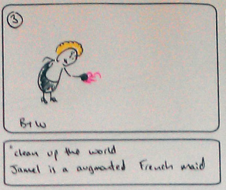  interaction: Jamel enters the scene with a french maid costume hovering in front of him  graphics: a cut out french maid's dress, cap and feather duster  sound: sweeping sound
4. I hope in the future the world is clean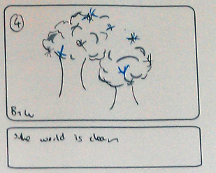  interaction: none - tree images shine and glint  graphics: images of trees  sound: sqeaking, 'ting'! | 5. we can all see in colour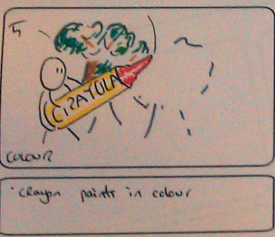  interaction: large crayon is held in 2 hands and paints in colour onto the background  graphics: trees and crayon  sound: chalk scrape | 6. the whole world accepts love  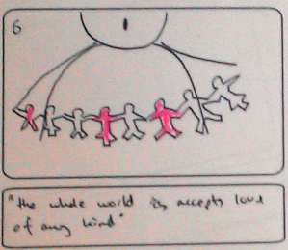  interaction: a paper chain of men and women appear between the speakers hands  graphics: cutouts images of men and women in different colours  sound: rattling paper, unscrumple
7. that's my dream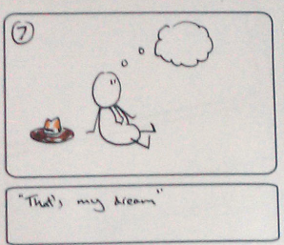  interaction: a thought bubble/cloud emerges from speakers head  graphics: thought bubble(s)  sound: bubbling sound | 8. there is a lot left to dream about  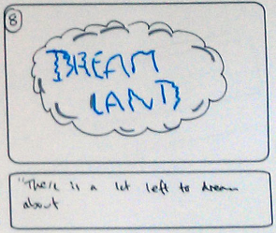  interaction: the cloud expands to fill the frame  graphics: same bubbles  sound: muffled growing sound (dream) | 9. what if i turned something?  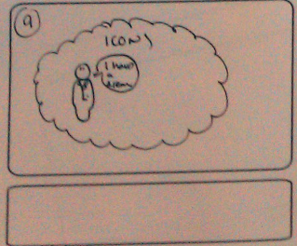  interaction: historical figures appear in the cloud  graphics: historical figuers  sound: ?
10. Reality could be so different  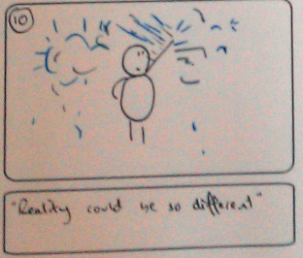  interaction: hand swipes disperse clouds  graphics: same clouds? clouds made of particles/fluids?  sound: ? | 11. Together we can make a change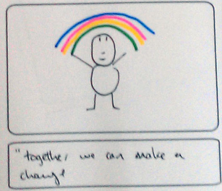  interaction: spreading arms create a rainbow  graphics: rainbow  sound: c major chord as a run up the scale | 12. Standing in our own shadow  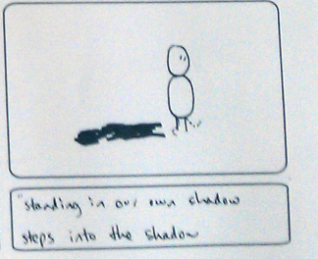  interaction: shadow appears under speaker. Speaker steps into their own shadow  graphics: shadow? in code?  sound: minor chord
13. Reach for the stars
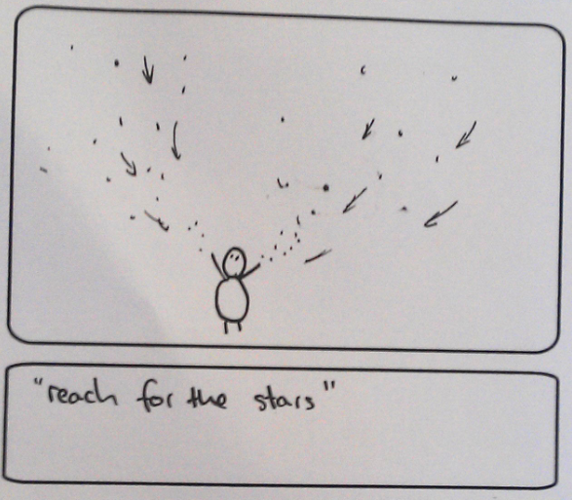
interaction: speaker lifts hands and stars are attracted to them
graphics: stars: in code
sound: twinkling/sucking into position

